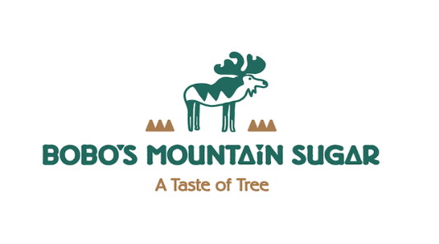
Sold To:
Name:
Contact phone number:
Email:
Ship To:
Name:
Address:
City:
State:
Zip:
Optional Gift Message:

Quantity:
_______ @ $25 per 1 pint (16oz) Bobo’s Mountain Sugar Maple Syrup

Price:
$ Syrup
$ 7.00 Shipping and handling
$ Total price

Payment:
Cash _____________________________
Check ____________________________
Credit Card Type: Credit Card Number:
Expiration Date: Security Code: Signature:
Bobo's Mountain Sugar 256 Dale Road Weston, VT 05161 802.296.1147 http://bobosmountainsugar.com
Office Notations:
Date order received:_________________________________ Date order processed:__________________________
Shipping notes: __________________________________________________________________________________

