AMERICAN HERITAGE AWARDS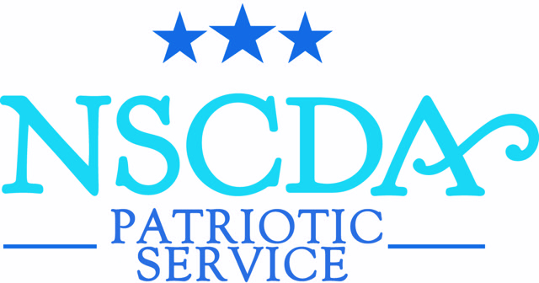

The American Heritage Awards celebrate the patriotic ideals of the NSCDA and bring together the Corporate Societies in support of each other.  An initiative for Dames to participate in their communities, the Awards are given to an organization, group, or as a student scholarship. The recipient or recipients must use the award to promote knowledge of patriotism and American heritage through community work, programs, projects, or through a course of study in the community.

These awards are a special opportunity for one Corporate Society, the Spotlight Society in each Region, to enhance a program, start an initiative, or move into a new direction in their communities.  The Spotlight Society selects the recipient or recipients for the year. The total amount of the award is determined by contributions of the Spotlight Society along with the contributions of other Corporate Societies in that region.  The National Patriotic Service Committee provides an honorarium to the Spotlight Society in each Region to support the initiative.

Guidelines and a Timeline are available by contacting Leslie Greene (CT), National Consultant, American Heritage Awards, at [Lesliemillsgreene@gmail.com](mailto:Lesliemillsgreene@gmail.com).

*The NSCDA Patriotic Service Committee thanks all Corporate Societies for helping to celebrate USA patriotism and heritage in the communities of our Societies throughout the USA.*

2023-2024 American Heritage Awards

Region I: Arizona Society Region II: Iowa Society

*Mission Garden, Tucson, AZ Quilts of Valor, Winterset, IO*

Highlights 4,000 years of Arizona’s diverse Provides homemade quilts to veterans.

cultural and agricultural heritage. Started in Iowa now has 10,000 volunteers ([missiongarden.org](http://missiongarden.org)) in all 50 states.

([qovf.org](http://qovf.org))

Region III: Tennessee Region IV: District of Columbia Society

*National Medal of Honor Heritage Center, Combat Soldiers Recovery Fund, Chattanooga Chevy Chase, MD*

This award will sponsor the Center’s 2023

annual Celebration of Valor.

Past American Heritage Awards

2022-2023

Region I: Kansas Society Region II: Missouri Society

*Friends of the Cherokee Trail FOCUS Marines Foundation, Augusta, MO*

Region III: Oklahoma Society Region IV: New York

*Tulsa Glassblowing School, Tulsa, OK Tuesday’s Children, Manhasset, NY*

2021-2022

Region I: Oregon Society Region II: Kentucky Society

*Portland Historical Society, Portland, OR Lady Veterans Connect, Winchester, KY*

Region III: North Carolina Society Region IV: Connecticut Society

*USO at Fort Bragg, NC 1. Boy Scout Troop 85, Wethersfield CT*

*2. Stonington Historical Society. CT*

| Upcoming Spotlight Societies | | | | |
| --- | --- | --- | --- | --- |
|  | REGION I | REGION II | REGION III | REGION IV |
| 2024-2025 | Nebraska | Ohio | Florida | Rhode Island |