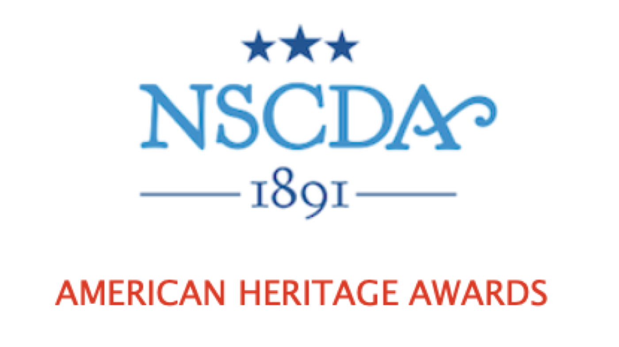
Guidelines and Timeline

The American Heritage Awards celebrate the patriotic ideals of the NSCDA and bring together the Corporate Societies in support of each other. An initiative for Dames to participate in their communities, the Awards are given to an organization, group, or as a student scholarship. The recipient or recipients must use the award to promote knowledge of patriotism and American heritage through community work, programs, projects, or through a course of study in the community.

Each year, eight Corporate Societies are designated as a “Spotlight Society.” The Spotlight Society designation is made on a rotation basis from eight groups made up of the 44 Corporate Societies. Every Corporate Society keeps its same place in the rotation from the earlier regional list.

The Spotlight Society selects the recipient or recipients for the year. The total amount of the award is determined by contributions of the Spotlight Society along with the contributions of other Corporate Societies in its group and a donation from the Scholarship, Grants & Awards Committee.

The NSCDA Scholarship, Grants & Awards Committee thanks you for participating in the celebration of patriotism as a Spotlight Society or as a Contributing Society.

GUIDELINES:
The criteria are broad so the Spotlight Society may be creative in its decision so long as the candidate meets the criteria of patriotism and heritage. It can be a Boy Scout troop, an Indian tribe, Junior ROTC at a high school, an ESOL program, a student of history at any level, a project at a VA Hospital--the list of programs/projects that meet our criteria is endless. The Spotlight Society can use the award for one or more recipients.
It is hoped that the Spotlight Society Patriotic Service Chair will ask for possible programs/projects from members of its Patriotic Service Committee or more broadly if she desires.
The Patriotic Service Chair must present the project in writing to the Spotlight Society’s Corporate Board and the Board must approve the project. The presentation must include at a minimum (1) a description of how the candidate/s meet the ideals of NSCDA Patriotic Spirit and (2) the amount sent in by other Corporate Societies in its group, the contribution of the Spotlight Society, and the NSCDA Scholarship, Grants & Awards Committee donation.
The American Heritage Awards funds may be given only to non-profit organizations. No American Heritage Award funds may be given directly to individuals. Relatives of Dames may not be considered for the American Heritage Award. We ask that every Corporate Society participate. There may be challenges at Corporate Societies, but full participation at some level is important.
After the project/candidate receives funding, the Spotlight Society should send a description, with photos if possible, to the Societies who participated by sending donations. This should also be sent to the Chair of the American Heritage Awards.
TIMELINE:
June:
The Chair of the American Heritage Awards contacts each Spotlight Society for the coming year to confirm participation. Attach the Guidelines and Timeline.
August/September:
The Patriotic Service Chairs of the other Corporate Societies in their Group are notified about that year’s awards, including a reminder to send a contribution to the Spotlight Society. The name and address of the contact/Treasurer at the Spotlight Society should be included so the Corporate Societies can easily send a donation.
November-April:
The proposed recipient/s must be approved by the Spotlight Society’s Corporate Society Board. The Patriotic Service Chair in the Spotlight Society presents candidate/s in writing to its Corporate Society Board for approval and includes the information noted in the Guidelines above.
January 15:
Most contributions should be received by the Spotlight Society from the other Corporate Societies in that Group. There is no deadline, but this helps the Spotlight Society know the amount they can work with. The amount of the contribution is voluntary and may change from Region to Region and from year to year.
The NSCDA Scholarship, Grants & Awards contribution of $1,000 will be sent to the Spotlight Society.
It is important that every Corporate Society participate. We are aware that there can be financial challenges in various Societies. While we hope each Corporate Society will give generously, it is more important to have full participation.
Ideas for a press release and other publicity are available to each Spotlight Society by request. Please contact the National Chair for the American Heritage Awards.
April 30:
The Spotlight Society should distribute the Award by April 30. NSCDA encourages the Spotlight Society to publicize the Award locally.
May 1-30:
The Spotlight Society sends a description of the Award recipient/s (with photos if possible) to the Corporate Societies in its group who have contributed to the Award. The description and photos should also be sent to the Chair for the American Heritage Awards.
This description should also be used for the next Scholarship, Grants & Awards eDispatch.

