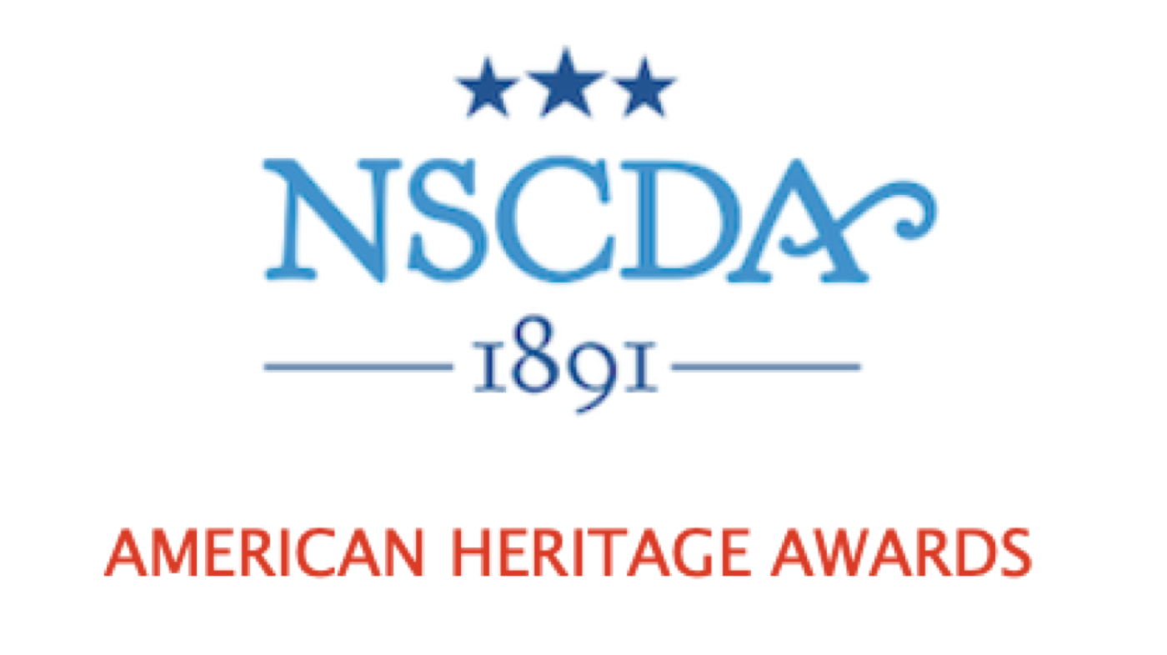

The American Heritage Awards celebrate the patriotic ideals of the NSCDA and bring together the Corporate Societies in support of each other. An initiative for Dames to participate in their communities, the Awards are given to an organization, group, or as a student scholarship. The recipient or recipients must use the award to promote knowledge of patriotism and American heritage through community work, programs, projects, or through a course of study in the community.

Guidelines and a Timeline are available on the NSCDA website under Scholarships, Grants & Awards. If you have any questions, please contact Leslie Greene (CT), Chair of the American Heritage Awards, at Lesliemillsgreene@gmail.com.

AMERICAN HERITAGE AWARDS SCHEDULE FOR 2024-2025

Spotlight Society I: Nebraska
Supporting Societies: Arizona, California, Colorado, Hawaii, Kansas, Nevada,
Oregon, Washington, Wyoming

Spotlight Society II: Ohio
Supporting Societies: Illinois, Indiana, Iowa, Kentucky, Michigan, Minnesota, Missouri

Spotlight Society III: Florida
Supporting Societies: Alabama, Arkansas, Georgia, Louisiana, Mississippi, North
Carolina, Oklahoma, South Carolina, Tennessee, Texas

Spotlight Society IV: Rhode Island
Supporting Societies: Connecticut, Washington DC, Delaware, Massachusetts, Maine,
Maryland, New Hampshire, New Jersey, New York, Pennsylvania, Vermont,
Virginia, West Virginia

AMERICAN HERITAGE AWARDS SCHEDULE FOR 2025-2036

 | AHA Group 1 | AHA Group 2 | AHA Group 3 | AHA Group 4
2025-2026 | California | Indiana | South Carolina | Massachusetts
2026-2027 | Washington | Michigan | Mississippi | Delaware
2027-2028 | Wyoming | Minnesota | Louisiana | New Jersey
2028-2029 | Nevada | Illinois | Georgia | Maryland
2029-2030 | Hawaii | Arkansas | Alabama | New Hampshire
2030-2031 | Colorado | Pennsylvania | Virginia | Vermont
2031-2032 | Texas | Oklahoma | West Virginia | Maine
2032-2033 | Oregon | Kentucky | North Carolina | Connecticut
2033-2034 | Kansas | Missouri | Tennessee | New York
2034-2035 | Arizona | Iowa | Florida | Washington DC
2035-2036 | Nebraska | Ohio |  | Rhode Island

PAST AMERICAN HERITAGE AWARDS
2023-2024
Region I: Arizona Society Region II: Iowa Society
Mission Garden, Tucson, AZ Quilts of Valor, Winterset, IA

Region III: Tennessee Region IV: District of Columbia Society
National Medal of Honor Heritage Center, Combat Soldiers Recovery Fund,
Chattanooga Chevy Chase, MD

2022-2023

Region I: Kansas Society Region II: Missouri Society
Friends of the Cherokee Trail FOCUS Marines Foundation, Augusta, MO

Region III: Oklahoma Society Region IV: New York
Tulsa Glassblowing School, Tulsa, OK Tuesday’s Children, Manhasset, NY

2021-2022

Region I: Oregon Society Region II: Kentucky Society
Portland Historical Society, Portland, OR Lady Veterans Connect, Winchester, KY

Region III: North Carolina Society Region IV: Connecticut Society
USO at Fort Bragg, NC 1. Boy Scout Troop 85, Wethersfield CT
2. Stonington Historical Society. CT

