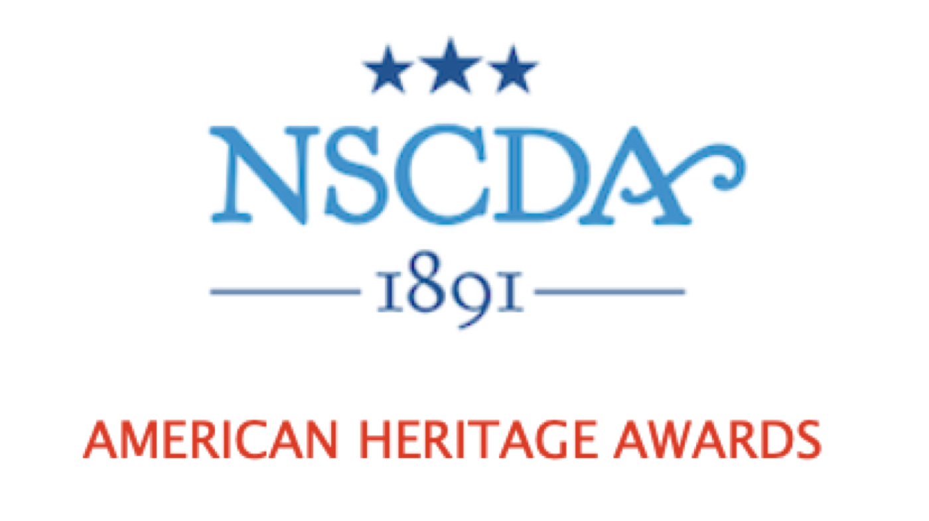
Purpose:

The NSCDA created this mission project in 2021 as a way for Corporate Societies to work directly with their local communities and support the NSCDA ideals of patriotism and appreciation of American heritage.

The awards recognize nonprofit organizations or groups whose work shows a dedication to patriotism and American heritage. The recipients must use this financial award to promote these values through their work.

How It Works:

Each year, 4 Corporate Societies serve as a “Spotlight Society.” The Spotlight Society designation is made on a rotating basis from 4 Groups made up of the 43 Corporate Societies. See the rotation schedule, below.

The Spotlight Society in each Group selects a recipient or recipients for the American Heritage Award. The recipient is usually a group that operates in the CS’s State, but a national organization may be selected as well. It is hoped that in the process of selecting an organization to honor, the CS and Award recipient will develop a relationship that continues to build in future years.

The Award Amount:

The total amount of the Award depends on the contributions from:

1) the Spotlight Society itself
2) each of the other Corporate Societies in the same Group, and
3) a donation of $1,000 from the NSCDA Scholarship, Grants & Awards Committee.

Donations from Supporting Societies this past year ranged from $100-$1,000.

100% Participation:
The NSCDA expects every Corporate Society to donate toward the American Heritage Award each year. One of the aims of this mission project is to encourage cooperation and support among the Corporate Societies. Every Society can take pride in the choices that the Spotlight Societies make!

2025-2026 Spotlight Societies:
Group I--California Spotlight Society

Supporting Societies: Arizona, Colorado, Hawaii, Kansas, Nebraska, Nevade, Oregon, Texas, Washington, Wyoming

Group II—Indiana Spotlight Society

Supporting Societies: Arkansas, Illinois, Iowa, Kentucky, Michigan, Minnesota, Missouri, Ohio, Oklahoma, Pennsylvania

Group III—South Carolina Society

Supporting Societies: Alabama, Florida, Georgia, Louisiana, Mississippi, North Carolina, Tennessee, Virginia, West Virginia

Group IV—Massachusetts Society

Supporting Societies: Connecticut, Washington DC, Delaware, Maryland, Maine, New Hampshire, New Jersey, New York, Rhode Island, Vermont

Rotation Schedule for 2025-2036:

 | AHA Group 1 | AHA Group 2 | AHA Group 3 | AHA Group 4
2025-2026 | California | Indiana | South Carolina | Massachusetts
2026-2027 | Washington | Michigan | Mississippi | Delaware
2027-2028 | Wyoming | Minnesota | Louisiana | New Jersey
2028-2029 | Nevada | Illinois | Georgia | Maryland
2029-2030 | Hawaii | Arkansas | Alabama | New Hampshire
2030-2031 | Colorado | Pennsylvania | Virginia | Vermont
2031-2032 | Texas | Oklahoma | West Virginia | Maine
2032-2033 | Oregon | Kentucky | North Carolina | Connecticut
2033-2034 | Kansas | Missouri | Tennessee | New York
2034-2035 | Arizona | Iowa | Florida | Washington DC
2035-2036 | Nebraska | Ohio |  | Rhode Island

Guidelines:

The criteria are broad so the Spotlight Society may be creative in its decision so long as the nonprofit group’s work supports the ideals of patriotism and heritage. The Spotlight Society may choose to use the Award for one or more recipients.
The NSCDA website has a list of the past recipients which indicate the broad range of possibilities. See “AHA List of Past Recipients” under the “American Heritage Award” page.
The CS’s President or Mission Chair/Patriotic Service Chair must present in writing a general description of the proposed recipient to the Spotlight Society’s Corporate Board, and the Board must approve the choice.
The AHA funds may be given only to non-profit organizations. No AHA funds may be given directly to individuals. Relatives of Dames may not be considered for the American Heritage Award.
Timeline:
May/June:
The Chair of the American Heritage Awards contacts each Spotlight Society for the coming year to confirm participation. The new Spotlight Societies are announced to all Presidents/Mission Chairs via the Mission Forward newsletter.
August/September:
The NSCDA AHA Chair notifies the Mission Chairs of the other Corporate Societies in each Spotlight Society’s Group that they should request that their Board approve and send a contribution to the Spotlight Society. The name and address of the Treasurer at the Spotlight Society should be included so the Corporate Societies can easily send a donation.
August-December:
Each Spotlight Society should choose the recipient(s) for the Award. The Mission Chair or President in the Spotlight Society must present the candidate in writing to the Corporate Society Board for approval.
January 15:
Contributions should be received from the Supporting Corporate Societies in each Group. This helps the Spotlight Society know the amount it will be able to disburse. The NSCDA Scholarship, Grants & Awards contribution of $1,000 is sent to each Spotlight Society in January as well.
April-May:
The Spotlight Society should distribute the Award in April or May. The Award can be given at a special ceremony or at a Dames Board or Annual meeting, as decided by the Spotlight Society and the recipient.
May-June:
The Spotlight Society should publicize news of the Award to its own membership and to the local community as appropriate. The Spotlight Society also sends a description of the Award recipient/s (with photos if possible) to the NSCDA AHA Chair, who disseminates this news to all Dames through an article in the eDispatch.

Questions:
Please reach out with any questions you may have. Contact Leslie Greene, NSCDA Scholarship, Grants and Awards Committee, Vice-Chair for the American Heritage Awards at (203) 246-6110 or Lesliemillsgreene@gmail.com.

