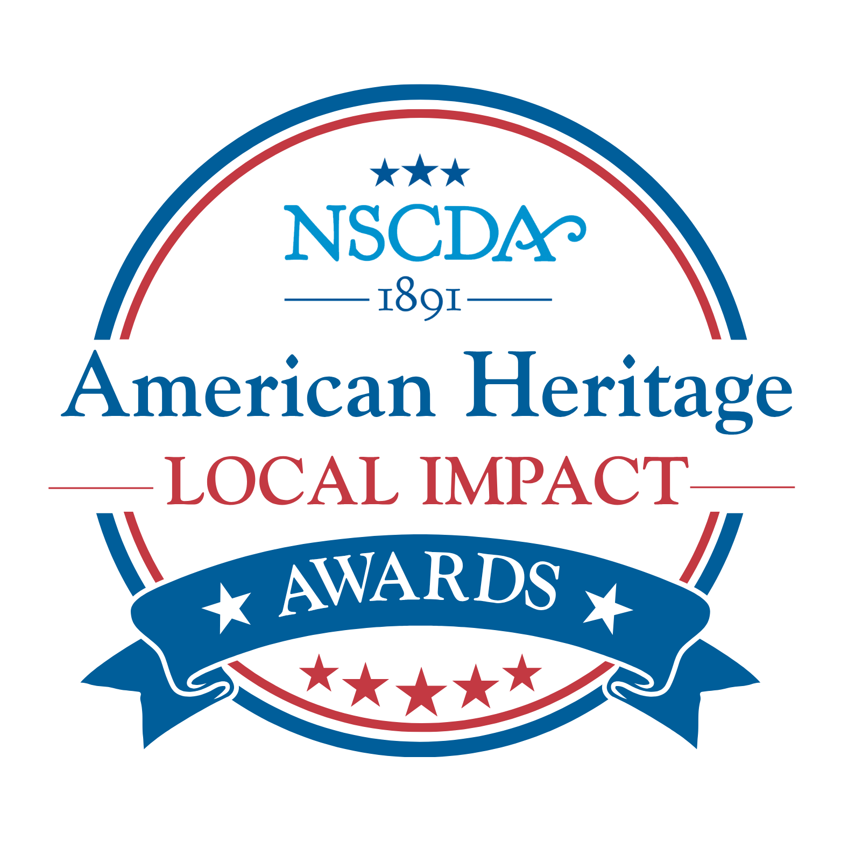
Purpose:

The NSCDA created the American Heritage Awards mission project in 2021 as a way for Corporate Societies to work directly with and impact their local communities.

The Awards recognize nonprofit organizations whose work shows a dedication to patriotism and American heritage. The recipients must use this financial award to promote these ideals through community programs or projects.

In June, 2026 the NSCDA announced a new name for the Awards, which are now known as the “American Heritage Local Impact Awards.” This change more accurately captures the spirit of this NSCDA mission: for Dames to make a difference in the local community.

How It Works:

Each year, four Corporate Societies from different parts of the country serve as Spotlight Societies responsible for choosing the Award winner in their State. The goal is for the Dames to make a meaningful impact and develop a relationship with an organization that is active anywhere in that state.

The Award Amount:

The Spotlight Society receives donations toward the Award from other Corporate Societies in their group, as well as a donation from the NSCDA.

Donations from Supporting Societies range from $100-$500, and the NSCDA contributes $1,000 to each Spotlight Society.

The size of the Awards given by the four Spotlight Societies range from $3500-$5000—a meaningful impact on the recipient organizations.

Guidelines:

The Spotlight Society may choose any nonprofit group whose work supports the ideals of patriotism and heritage. Ideally, the nonprofit is an organization the Spotlight Society already has a relationship with or is one that some Corporate Society members work with and recognize for their contribution to the community. The Award is not about choosing the “best” nonprofit within a state. The Spotlight Society may choose one or two recipients, but we strongly encourage choosing one as the financial Award will be more impactful if it isn’t split between two nonprofits.
The funds are given only to nonprofit organizations. No funds may be given directly to individuals. Relatives of Dames may not be considered for the Award.
See the “List of Past Recipients” on the NSCDA website to learn about the organizations that have been honored with the Awards. To access, see “NSCDA Website” below.
Timeline:
May:
The NSCDA Chair of the Awards contacts each Spotlight Society for the coming year to confirm participation. The NSCDA Chair announces the four new Spotlight Societies to all CS Presidents and Mission Chairs via the Mission Forward newsletter.
June-September:
Each Spotlight Society works over the summer to identify the non-profit organization that they would like to support with the American Heritage Local Impact Award. The Spotlight Society notifies the NSCDA Chair once a decision has been made.
The deadline for each Spotlight Society to make its decision is September 30. The earlier the decision is made, the better the choice can be publicized to the Supporting Societies.
September:
Each Spotlight Society obtains Board approval of its choice for the Award by September 30. The President or Mission Chair presents in writing a short description of the organization and how it upholds the ideals of the NSCDA. The Spotlight Society also determines how much it will contribute to the Award.
Each Spotlight Society announces its choice directly to the Presidents and Mission Chairs in their group. The announcement includes the name and address for the Spotlight Society Treasurer so that donations may be sent directly to the Treasurer. See the “Announcement” template on the NSCDA website.
The NSCDA Chair also announces the four Spotlight Society nonprofit selections nationally via the Mission Forward e-blasts. The announcement includes the Treasurer’s information for each Spotlight Society.
Each Supporting Society determines the size of its contribution to the Award. The Patriotic Service Chair requests funding for the Awards on an annual basis as a line item in the Society’s budget.
September-December: Each Supporting Society sends its contribution to the Spotlight Society. Donations from each Supporting Society are due no later than January 1st.
The President of the Spotlight Society acknowledges receipt of each donation with a thank-you note to the President of the Supporting Society. See the “Thank You” template on the NSCDA website.
The Treasurer of the Spotlight Society notifies the NSCDA Chair upon receipt of each donation from the Supporting Societies, including the amount of the donation.
December:
On December 1st the President of the Spotlight Society sends a reminder to each Supporting Society who has not yet sent a contribution. See the “Reminder” template on the NSCDA website.
January: The NSCDA sends a contribution to each of the four Spotlight Societies in support of the Award.
February-March: The Spotlight Societies make plans with the Award winner for the presentation of the American Heritage Local Impact Award to be held anytime in the Spring. A ceremony can take place, for example, during the Spotlight Society’s Annual Meeting or else at the recipient organization itself.
The Spotlight Society prepares an Award Certificate to present to the winner. See the “Award Certificate” template on the NSCDA website.
April-May: The Spotlight Societies present the Awards. After the ceremony, the Spotlight Society sends photos and descriptions to the NSCDA Chair for publicizing through the eDispatch and other NSCDA media. The Spotlight Society also publicizes news of the Award to its own membership and to the local community as appropriate.

2026-2027 Spotlight Societies:
Group I—Washington Society

Supported by: Arizona, California, Colorado, Hawaii, Kansas, Nebraska, Nevada, Oregon, Texas, Wyoming

Group II—Michigan Society

Supported by: Arkansas, Illinois, Indiana, Iowa, Kentucky, Minnesota, Missouri, Ohio, Oklahoma, Pennsylvania

Group III—Mississippi Society

Supported by: Alabama, Florida, Georgia, Louisiana, North Carolina, South Carolina, Tennessee, Virginia, West Virginia

Group IV—Delaware Society

Supported by: Connecticut, Washington DC, Maryland, Massachusetts, Maine, New Hampshire, New Jersey, New York, Rhode Island, Vermont

Rotation Schedule for 2026-2037:

 | AHA Group 1 | AHA Group 2 | AHA Group 3 | AHA Group 4
2026-2027 | Washington | Michigan | Mississippi | Delaware
2027-2028 | Wyoming | Minnesota | Louisiana | New Jersey
2028-2029 | Nevada | Illinois | Georgia | Maryland
2029-2030 | Hawaii | Arkansas | Alabama | New Hampshire
2030-2031 | Colorado | Pennsylvania | Virginia | Vermont
2031-2032 | Texas | Oklahoma | West Virginia | Maine
2032-2033 | Oregon | Kentucky | North Carolina | Connecticut
2033-2034 | Kansas | Missouri | Tennessee | New York
2034-2035 | Arizona | Iowa | Florida | Washington DC
2035-2036 | Nebraska | Ohio |  | Rhode Island
2036-2037 | California | Indiana | South Carolina | Massachusetts

NSCDA Website:
To access the “List of Past Recipients” and the templates referenced herein, visit the NSCDA website at https://nscda.org/ The username is “preservation” and the password is “purpose1891!” Then choose “Scholarship, Grants and Awards” and scroll to “American Heritage Local Impact Awards.” Click the links to “Past Recipients” or to the templates mentioned above.
Questions:
Please reach out with any questions you may have. Contact Leslie Greene, NSCDA Vice-Chair for the American Heritage Local Impact Awards, at (203) 246-6110 or Lesliemillsgreene@gmail.com.

